Chapter 13, Problem 69.

In the circuit of Fig. 13.132, Z_{L} is adjusted until maximum average power is delivered to Z_{L}. Find Z_{L} and the maximum average power transferred to it. Take N₁ = 600 turns and N₂ = 200 turns.

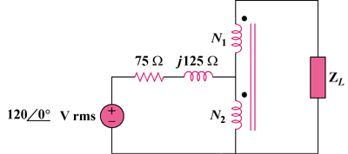

Figure 13.132
For Prob. 13.69.

